
General Manager (S & M - CM)
Sales & Marketing - Consumer Mobility
3rd Floor, New CTS Building
16, Greams Road, Chennai – 600 006
Phone: 044-28297878 Fax: 044-28297979

S&M-CM/170/Tariff/11-12/104 dt @ Chennai-6 the 01/01/2012

Sub: Revision in tariff of C-top-up SIM - reg.

Ref: CO No. 26-11/2007-R&C Circular T&C CM No. 110/11-12 Date: 25.01.2012.

W.r.t the above cited CO order, approval of competent authority is hereby conveyed for the implementation of revision of the tariff applicable to C-TOP UP SIM in Tamilnadu LSA(incl CHTD) w.e.f 01.02.2012 as under :

The minimum transaction requirement per month for C-Top-up SIMs for availing the special tariff is reduced from Rs.3000 to Rs.1000 per month for urban retailers also .The special tariff is for those channel partners as per the list that will be provided by Sales wing every month

All other existing terms and conditions will remain same.

This is for information of all concerned please

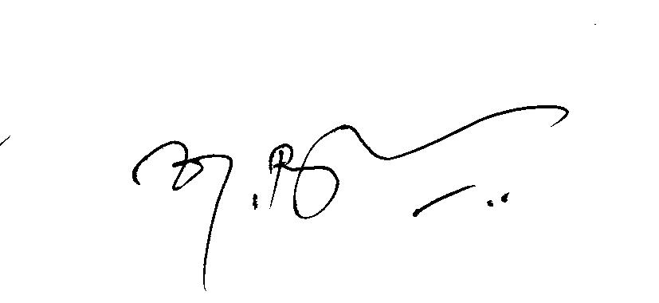

(K. Rathakrishnan)
DGM (Sales/MKTG-CM)

TN Circle, Chennai

To

GM (NW-O CM), Trichy -1/ Coimbatore – For information & necessary action please.
GM(S&M-CM), Chennai Telephones, Chennai for information pl.
GM (F) / Sr. GM (TR) TN Circle, Chennai for information please.
DGM/DE In charge IN - Trichy - for necessary action please.
DGM(NW-O)/DE Commercial, Coimbatore - For information & necessary action please.
Heads of SSAs, -- for kind information and necessary action please.
DGM (Sales) & AGM (Sales), Chennai-6 –For information and informing Sales Heads , franchisee managers and retail managers and other Channel partners along with commission structure as applicable.
DGM (CS), Chennai-6 - For information and informing Call Centre/Customer Service Centre Officials and ensure uploading the information on the website “tamilnadu.bsnl.co.in” .

